ASSIGNMENT 4 ( Quick Sort )
CODE :
//Merwin Pinto
//202100102
//Div D
#include<stdio.h>
int elementpartion(int array[] ,int low , int high);
void quicksort(int array[],int lower , int higher) ;
void swap(int* a, int* b);
void printarray(int array[], int size);
int main() //main function
{
printf("Program on QUICK SORT ! \n\n");
int n,i,array[100];
printf("Enter for how many elements you need : ");
scanf("%d",&n);
for(i=0;i<n;i++) //no of elements
{
scanf("%d",&array[i]); //array of elements to be sorted
}
printf("Unsorted array : \n");
printarray(array, n); //printing unsorted array

printf("\n\nSorted array: \n");
quicksort(array, 0, n - 1);
printarray(array, n); //printing sorted array
return 0;
}
void quicksort(int array[],int lower , int higher) //quicksort algorithm
{
int index;
if(lower < higher)
{
index = elementpartion(array ,lower ,higher);
quicksort( array, lower, index - 1);
quicksort( array, index + 1, higher);
}
}
int elementpartion(int array[] ,int lower , int higher) //seperation of elements algorithm
{
int i, j, k;
int pivot; //declaring pivot
pivot = array[higher] ; //pivot assigned to higher value
i = lower - 1;
k = lower;
for(j = k ; j<= higher-1;j++)
{
if(array[j]<= pivot) //comparing elements with pivot
{
i++;
swap(&array[i],&array[j]); //swapping the correct compared values
//call by reference
}
}
swap(&array[i+1],&array[higher]);
return(i+1);
}

void swap(int* a, int* b) //function for swapping elements
{ //pass by reference
int temp = *a;
*a = *b;
*b = temp;
}

void printarray(int array[], int n) //function for printing array
{
int i;
for (i = 0; i < n; i++)
{
printf( "%d \t", array[i]);
}
}

OUTPUT :
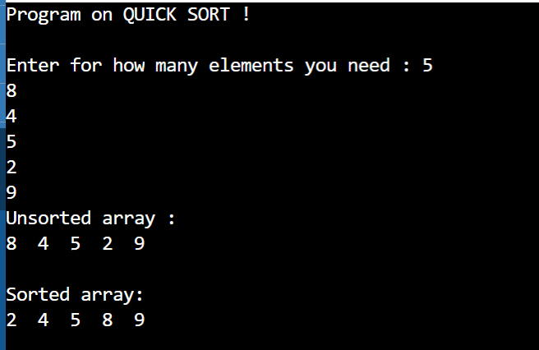

ASSIGNMENT 4 ( MERGE SORT )
CODE :
//Merwin Pinto
//202100102
//Div D
//Merge sort
#include <stdio.h>
void merge(int array[], int First, int middle, int last) ;
void mergeSort(int array[], int First, int last);
void display(int array[], int n);
int main()
{
printf("program for MERGE SORT !\n\n");
int n,i, array[100];
printf("Enter for how many elements you need : "); //no of elements
scanf("%d",&n);
for(i=0;i<n;i++)
{
scanf("%d",&array[i]); //array of elements to be sorted
}
printf("\nUnsorted Array : \n"); //Unsorted elements
display(array, n);

printf("\nSorted Array \n"); //sorted elements
mergeSort(array, 0, n - 1);
display(array, n);
return 0;
}
void merge(int array[], int First, int middle, int last)
{
int i, j, k;
int n1 = middle - First + 1;
int n2 = last - middle;

int LeftArray[n1], RightArray[n2];

for (i = 0; i < n1; i++)
{
LeftArray[i] = array[First + i]; //left array distribution
}

for (j = 0; j < n2; j++)
{
RightArray[j] = array[middle + 1 + j]; //right array distribution
}

i = 0; // first sub-array
j = 0; // second sub-array
k = First; // sub-array

while (i < n1 && j < n2)
{
if(LeftArray[i] <= RightArray[j]) //comparing elemts of left and right array
{
array[k] = LeftArray[i];
i++;
}
else
{
array[k] = RightArray[j];
j++;
}
k++;
}

while (i<n1)
{
array[k] = LeftArray[i];
i++;
k++;
}

while (j<n2)
{
array[k] = RightArray[j];
j++;
k++;
}
}

void mergeSort(int array[], int First, int last) //Merge sort Function holding algorithm
{
int middle;
if (First < last)
{
middle = (First + last) / 2;
mergeSort(array, First, middle);
mergeSort(array, middle + 1, last);
merge(array, First, middle, last);
}
}

void display(int array[], int n) //function for printing array to be sorted
{
int i;
for (i = 0; i < n; i++)
{
printf("%d ", array[i]);
}
printf("\n");
}
OUTPUT :
